Design Ventura 2021-22

Online Mini Challenge: Waste

The Design Ventura online mini challenge invites students to 'design with waste in mind' by coming up with an idea for a new product for the Design Museum Shop that either tackles a waste issue or is made from a waste material.

This list of designers and products below is to help you inspire your students when coming up with ideas in response to the brief. These examples either relate to the Design Museum's Waste Age exhibition or products sold in the Design Museum Shop.

Plastics

Thinking about products that reduce, reuse or recycle plastic is a good way of designing with waste in mind:
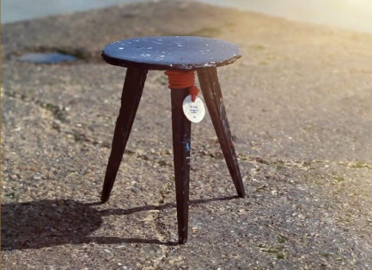
Sea Chair
Designer: Studio Swine
About: a stool made from recycled sea plastic.
Link: Studio Swine

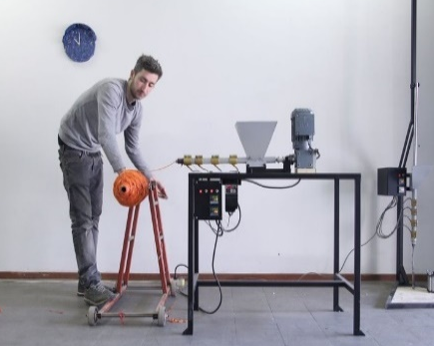
Precious Plastics Global Community
Designer: Precious Plastics
About: a community dedicated to recycling plastic. They have designed open-source machines, tutorials, kits and templates to help people start recycling plastic.
Link: Precious Plastics

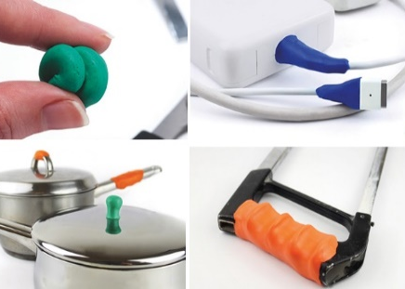
Sugru
Founder: Jane Ni Dhulchaointigh
About: a moldable glue that reduces waste by allowing people to extend the life of their products by fixing or improving them.
Link: Sugru

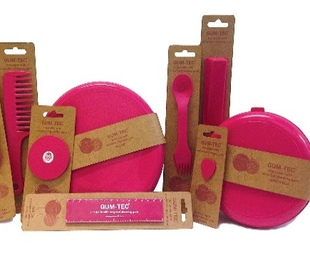
GumTec
Founder: Anna Bullus

About: recycled chewing gum used to create new products. Used for the Design Ventura winning product Petal Pot, which was sold in the Design Museum Shop.

Link: Gum Drop

Biomaterials

Thinking about innovative, new materials made from natural alternatives is another way of designing with waste in mind:
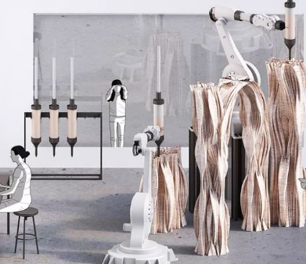
Mycelium
Designer: Blast Studio

About: using funghi to breakdown waste to create a strong new material that can be 3D printed.

Link: Blast Studio

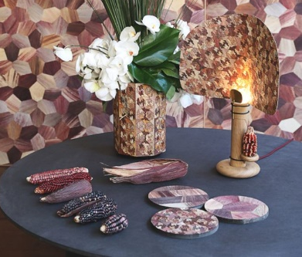
Totomoxtle
Designer: Fernando Laposse

About: using corn husks (a waste material from corn production) to create decorative objects.

Link: Totomoxtle

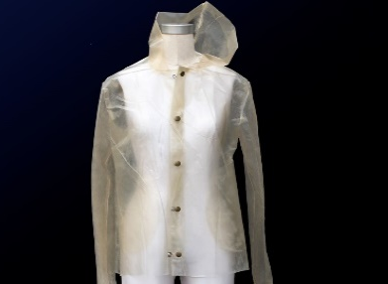
Algae Fashion
Designer: Charlotte McCurdy

About: a carbon negative rain jacket made from algae rather than plastic.

Link: Ancient Sunlight

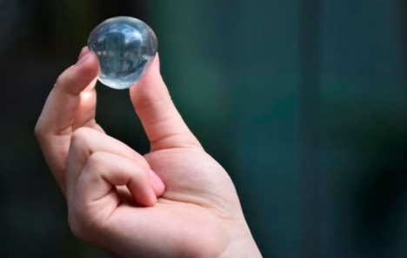
Edible Algae
Founders: Rodrigo García González, Pierre Paslier and Guillaume Couche

About: an alternative to plastic bottles, an edible algae membrane used to contain water and other liquids.

Link: Ooho Water

Design Museum Shop Products

Existing products on sale in the Design Museum Shop that look to tackle waste.

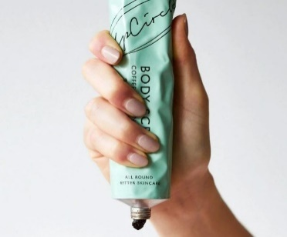
Coffee Body Scrub
UpCircle Beauty
About: natural body exfoliator made with repurposed coffee grounds from London cafes. Retail price: £18.00

Link: the Design Museum Shop

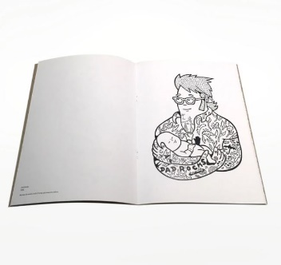
Scrap Paper Colouring Book
Scrap Pad and Mormor

About: a colouring book including 15 illustrations by Danish street artist Mormor, printed on 100% leftover paper. Retail price: £12.00

Link: the Design Museum Shop

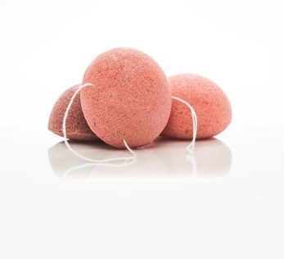
Konjac Sponge
Tabitha Eve
About: an all-natural replacement for the natural sea sponge (which is a living creature) or plastic sponges, made from the root of a konjac plant. Retail price: £6.00

Link: the Design Museum Shop
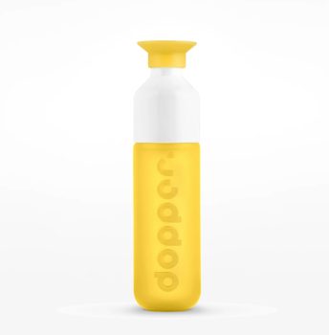
Dropper Water Bottle
Dropper
About: a water bottle made from 100% recyclable materials. When removed, the top doubles as a cup. Retail price: £12.00

Link: the Design Museum Shop
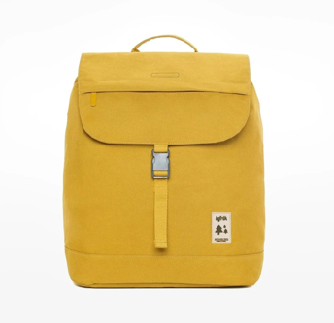
Scout Backpack
Lefrik
About: a backpack made from recycled polyester and PET bottles. Each backpack is made using 24 bottles. Retail price: £45.00
Link: the Design Museum Shop

