Design Ventura 2023-24

Online Mini Challenge: Community

The Design Ventura Mini Challenge is open to students in Years 7 - 11. The theme for this year’s mini challenge is Community, inspired by the Design Museum’s REBEL: 30 years of London Fashion exhibition.

This list of designers and products below is to help you inspire your students when coming up with ideas in response to the brief. These examples relate to the theme of community and are sold in the Design Museum Shop.

Design Museum Shop Products
Some of these are similar kinds of products: interpretations of the same brief. What decisions have been made to make them different? Who might buy the different products?

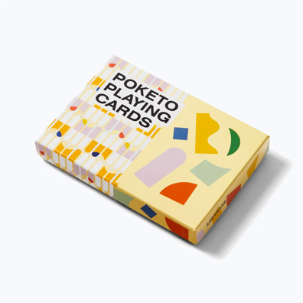
Poketo Playing Cards
Areaware
Retail price: £30.00
the Design Museum Shop

Play your most artful game with this set of colourful playing cards
Each deck is suited up in vibrant colours and shapes. Includes two decks of playing cards, each with a different design

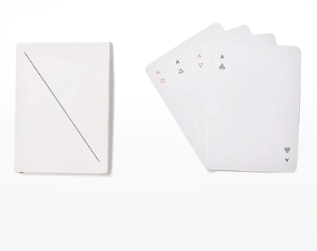
Minim Playing Cards
Stone Marketing
Retail price: £15.00
the Design Museum Shop

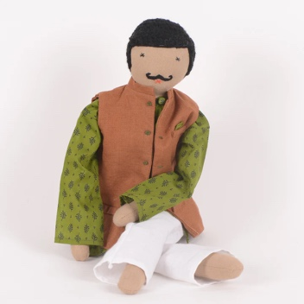
Minim is a deck of regulation playing cards that explores how much “design” can be removed while still maintaining a playable deck. Traditional hearts, clubs, diamonds and spades are replaced with minimalist geometric symbols. Regulation playing cards require that the backs be marked, so Minim utilises a subtle diagonal line.
Silawali Chacha Doll
Silawali
Retail price: £50.00

Silawali, based in New Delhi, employ women refugees to hand-make their products using fashion industry waste. This is environmentally and socially sustainable, as it supports communities of marginalised artisans.

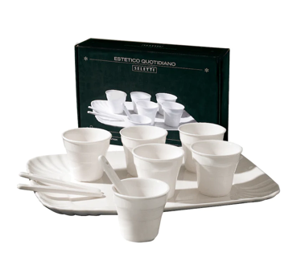
Porcelain Coffee Set of 6
Seletti
Retail price: £50.00
the Design Museum Shop

Minimalistic set of six coffee cups. Expertly crafted from 100% porcelain, each mug features a smooth, glossy finish. A sustainable set with a design inspired by single-use products.

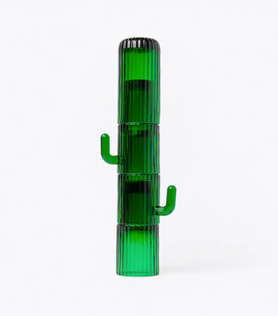
Saguaro Cactus Glasses
The Design Museum (for Objects of Desire exhibition)
Retail price: £72.00
the Design Museum Shop

Quench your thirst with these fluted, green, long drink glasses; a set of 4 which when stacked together form the shape of a Saguaro cactus. Dishwasher safe!

Design Ventura Past Products
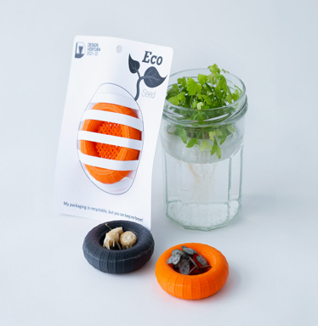
Eco Seed
Cambourne Village College
Design Ventura website

A doughnut shaped grid which floats on water keeping seeds moist and provoking them to germinate. 2021-22 winning product.

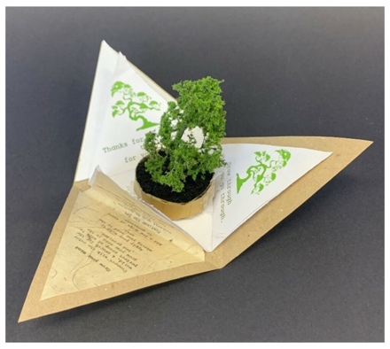
Positivitree
Davison C of E High School for Girls
Design Ventura website

A giftable plant in pyramidal packaging that is aimed at boosting mental wellbeing. 2020-21 second place product.

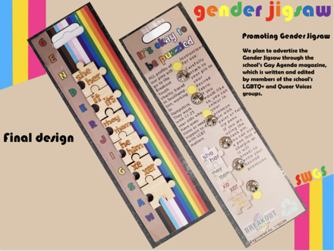
Gender Jigsaw
South Wiltshire Grammar School Design Ventura website

Jigsaw pieces with pronouns, to be worn on your clothing and let those around you know how they can refer to you.

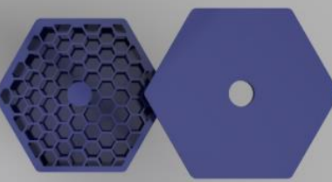
Bee Buddy (BBDY)
Upton-by-Chester High School Design Ventura website

A reusable bee-house for your garden, to provide bees with both food and shelter.

