Mini Challenge inspiration

How GCSE curriculum designers incorporate ‘community’

One way to be inspired for your Design Ventura Mini Challenge project is to think about designers you admire (perhaps some you have learned about at school) and how their designs evoke ‘community’. This can help you decide how you might like to interpret the theme.

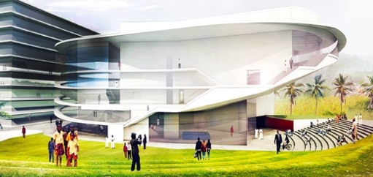
ARCHITECTURE AND SPACES
Kumasi City Hall by Elsie Owusu [link to portfolio]
Elsie Owusu’s designs are often influenced by local history and culture. This city hall she designed for Kumasi, a city in Ghana’s Ashanti region, is inspired by the Ashanti national animal, the porcupine.

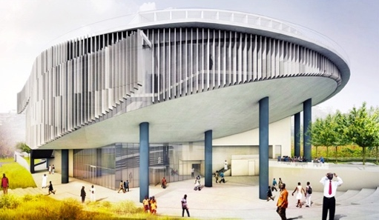
Environmental impact is an important part of community responsibility. This city hall was to be built in locally sourced, sustainable materials. Local materials are innately more sustainable as less carbon is emitted in transportation. They also further connect to the local area and economy.

Even the initial image Owusu rendered to communicate and pitch her design shows people wandering around the building, reflecting its position within and for the community. Think about how you communicate!
Block Cubes by Yinka Ilori [link to portfolio]
Yinka Ilori’s colourful designs strive to be joyful and inclusive. He often designs for play – basketball courts, playgrounds – and aims to “never underestimate the power of the community, and of people coming together to play”.

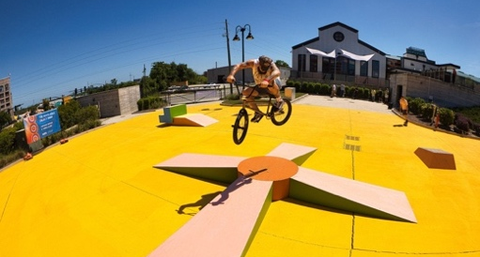
These Block Cubes are modular components for a skate park. They can be combined in different ways and integrated into an existing space (ideally painted in joyful colours to match the blocks!) such as a converted warehouse or a disused carpark – places that no longer have a place in the community, but can become useful and beautiful again.

“Skateboarding is not only about skating, but it's also about being part of a community, it's also being part of a family” – Yinka Ilori

FASHION AND TEXTILES
‘Taith’ collection by Sian O’Doherty [link to lookbook]
Sian O’Doherty designs and makes knitwear. She grew up in Pembrokeshire and still lives in Wales, along with her family and a small farm of alpacas who often provide wool for her work. In this way, her entire making process is arguably a product of community, with the alpacas being community members!

All of O’Doherty’s collections are named in Welsh. “Taith” means “a journey”, and she says “the comforting warmth of a lambswool wrap is always a welcome travel companion”. Like most of her designs, many pieces in the collection feature high-contrast, repeating geometric designs that evoke the designs on traditional Welsh “Carthen Ysgafn” blankets. Knitting itself is also a huge part of traditional Welsh culture, although traditionally done with sheeps’ wool rather than alpacas’. In this way O’Doherty constantly brings the history of her wider community into her work and helps keep it alive and innovating.
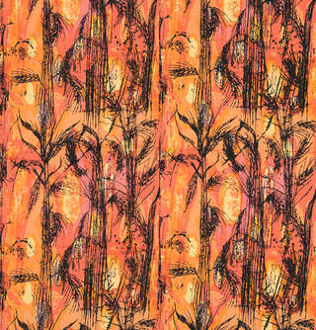
‘Golden Harvest’ furnishing fabric by Althea McNish [link to reading]
Althea McNish was one of the first Black designers to be globally recognised for her signature ‘freehand’, painterly style and use of colour.

McNish grew up in Trinidad before moving to London in 1951, where she initially studied printmaking before focusing on textiles. She often combined visual motifs from these two communities, and ‘Golden Harvest’ is an early example of this: when McNish first encountered a wheat field, in Essex, she was reminded of sugar cane plantations she had seen in Trinidad as a child. Her design features a plant that could be recognised as either a wheat sheaf or a sugar cane stalk, and her “tropical eye” for colour brings a vibrant glow into the palette that was very unusual, particularly for home furnishings, but much welcomed in post-war Britain.
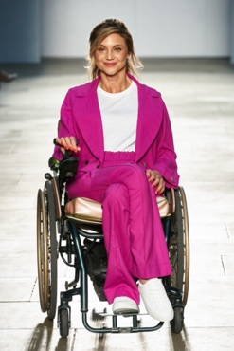
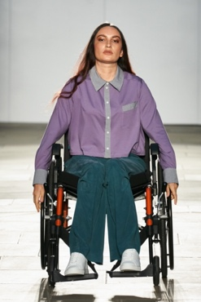
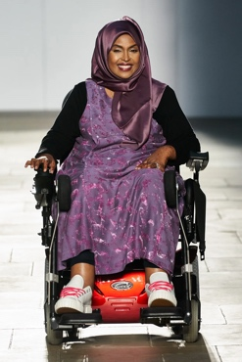
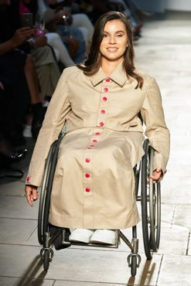
Faduma’s Fellowship collection London Fashion Week 2021, by Faduma Farah x Harriet Eccleston [link to reading]
This fashion show was a collaboration: Faduma Farah partnered with independent designer hub Oxford Fashion Studio to found Faduma’s Fellowship, and Harriet Eccleston was their first beneficiary.

Progress in accessible design unfortunately often depends on members of marginalised communities, and Farah’s Fellowship is no exception. Farah’s lived experience of using a wheelchair and Eccleston’s pattern-cutting expertise meant they could “learn from each other, all the way up to the runway”. Together, they created the first collection of clothing specifically for wheelchair users ever to show at London Fashion Week.

Some examples of the adaptive designs were waistlines raised at the back; crotch seams cut generously to make sitting in the chair more comfortable; pockets moved to the sides; and pleats added to knees to reduce discomfort or restricted circulation.
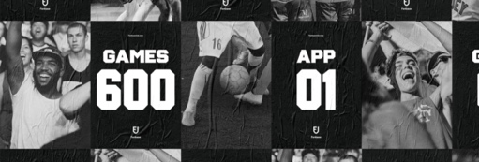
GRAPHIC DESIGN
Fanbase by Daniel Freytag and Greig Anderson [link to portfolio]
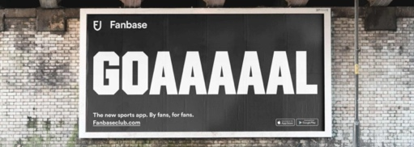
The founders of Fanbase, Mikey and Ali, are sports fans who wanted to create a platform connecting fans and clubs across the world. Fans would be able to support and interact with their clubs, while clubs would be more able to monitor and understand how their fan communities interacted with them. The idea was for sports communities to be better able to engage and support one another on both the human and the commercial scale.

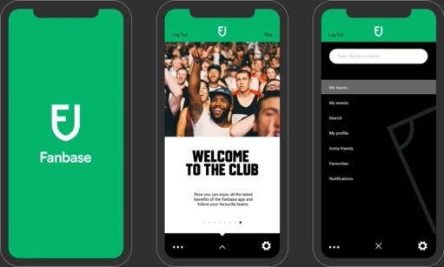
Consistent graphics across the system reflect Mikey and Ali’s dream of a unified, communicative mega-community of sports fans, while paying homage to existing, familiar iconography. The Fanbase logo and typography for example are inspired by club crests and the typeface used for sports jerseys and football shirts across the world. The colour palette is a versatile, “no nonsense” black and white “complimented by a vibrant green” to symbolise the grassroots spirit of the system and of sporting communities in general.
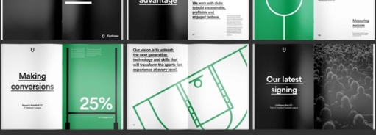
Implementing Fanbase across digital and print platforms (in these pictures you can see how Fanbase’s graphic design works seamlessly across mobile app, poster/billboard, and magazine contexts) also ensures that it is accessible across the sports community, aiming to leave nobody out.
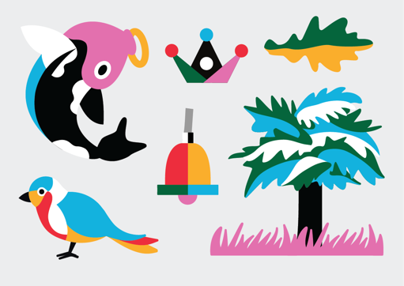
Glasgow Queen Street station by Gabriella Marcella [link to portfolio]
Visual design is often a very important part of making public spaces feel welcoming and vibrant, and can impact people’s use of the space to actually be a part of its improved functionality. This is why you will often see arts and culture initiatives centred around, for example, a train station. In this case we have Glasgow Queen Street, which was to be totally rebuilt while remaining usable throughout with minimal disruption.
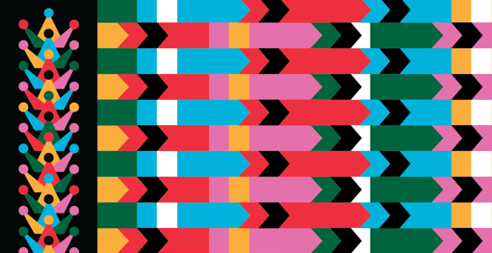
Gabriella Marcella’s designs for the station are immediately colourful and inviting, but they are also packed full of references to Glasgow’s community. For instance, the first image to the left is a set of motifs all rendered in the same vibrant palette and style, all of which are integral to the Glasgow City Crest. These can be combined with one another and with other imagery in the same palette/style to create a cohesive and adaptable brand aesthetic which is always anchored in the city history. You can see a couple of examples of these motifs being manipulated – through scale, repetition, and reorientation – into more abstract patterns beneath the set of foundational motifs to the left.
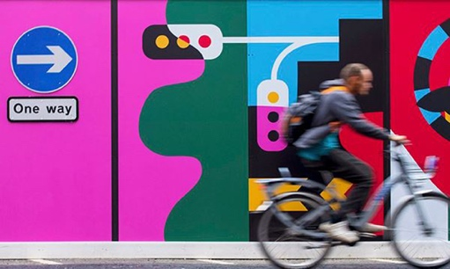
The rebrand also incorporates familiar visual language of railway signals and other signage – but importantly, the playful colours and style separate the purely aesthetic from the functional (e.g. a one way road sign)! Members of the public inhabiting the space keep it dynamic, relevant, and visually connected to the community it is intended to serve.
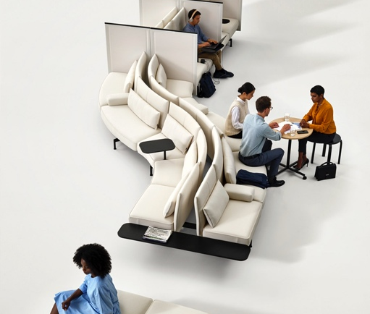
FURNITURE DESIGN
Soft Work system by Barber & Osgerby [link to portfolio]
This system began in 2018 as a response to shifts in working habits and office structures: open offices, co-working spaces, and working from your laptop or smartphone ‘on the go’ were becoming ever more common. During the COVID-19 pandemic, design for non “desk-centred” workspaces became more relevant than ever. Barber & Osgerby see this as a new or potential kind of community: “the office of the future will be a gathering space, facilitating interaction and collaboration.”

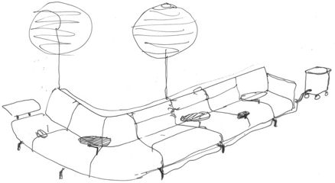
Soft Work uses modular pieces to build a “seating landscape” that is versatile and comfortable for work that would traditionally be done in an office. Pivoting tables include a larger option that has space for 3-4 teammates “to gather for meetings or coffee breaks”, power sockets, and partition screens. Seats can be single-sided, back-to-back, or even curve and loop round on themselves thanks to options from curving to fully linear arrangements. While the Soft Work system is not necessarily a community-centring workspace option, it certainly can be.
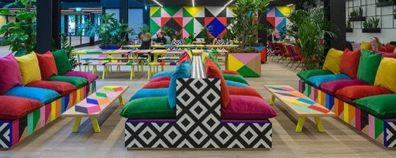
Atoll structure and furniture by Morag Myerscough [link to portfolio]
Myerscough’s mantra is “make happy those who are near and those who are far will come”, so her designs respond to local communities and often directly engage them in the design process. For instance, in 2017 she ran pattern workshops for Artskickers volunteers to then incorporate into that year's stage for the Artskickers People’s Choice Award.

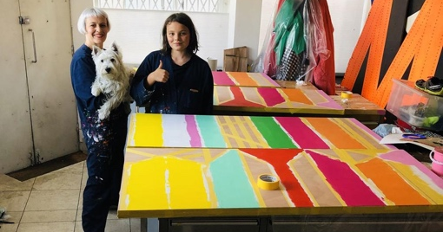
This project aimed to revive a formerly private corporate space and make it both accessible and welcoming to the general public. Myerscough’s characteristic rainbow palette and tessellating patterns make the space cheerful and engaging. Different combinations of tables and seating accommodate individuals and groups of all sizes. Soft furnishings, a variety of seating to cover several access needs, and plenty of power sockets ensured people could comfortably stay in the space for hours.

Myerscough’s regular partner, Luke Morgan, specialises in metal work and worked with her to design the metal table legs and the plant wall, and all furniture was manufactured by a small team in their studios.

Selected from AQA and Pearson suggested designers lists, academic year 2023-24

